PiXL

A Social Media Platform for Foodies!

***REQUIREMENTS DOCUMENT***

|  |  |  |  |
| --- | --- | --- | --- |
| **Version** | **Summary** | **Description** | **Date** |
| v1 | First Version | First release of the requirements document | 10/09/2024 |

**TABLE OF CONTENTS**

1 USER REQUIREMENTS 1

1.1 MUST-HAVE REQUIREMENTS 1

1.2 NICE TO HAVE REQUIREMENTS 1

1.3 NON-FUNCTIONAL REQUIREMENTS 2

2 SYSTEM REQUIREMENTS 3

3 CONSTRAINTS 3

4 SYSTEM ARCHITECTURE 4

5 SYSTEM MODELLING 5

5.1 USE CASE DIAGRMS 5

5.1.1 Use Cases 5

5.1.2 Use Case Diagrams 6

5.2 SEQUENCE DIAGRAMS 12

5.3 CLASS DIAGRAMS 16

**INTRODUCTION**

PiXL is a food-sharing social media platform designed to bring food enthusiasts, chefs, restaurants, and culinary professionals into a vibrant community where they can share food photography, sacred menu items for different restaurants, and personal culinary experiences. By sharing images and videos of food content and recipes, users can interact with others through comments, and likes, and discover trending accounts and content. The platform aims to connect people through their passion for food.

The target users of the system include restaurants aiming to engage potential clients, chefs seeking to showcase their skills, and individuals with an avid interest in the latest food fads. The system will have user accounts showing a timeline with images, short videos, and recipes.

**GLOSSARY**

Foodie: A person who loves food and is interested in different types of food.

Frontend: The part of the application the user will interact with

MySQL: an open-source relational database management system that is used to store and manage data

PiXL: The social media for foodies’ application being developed

UI: The UI is the User Interface. It is the part of the application that the user will interact with

# USER REQUIREMENTS

## MUST-HAVE REQUIREMENTS

1. **As a user**, I want to create a profile with a bio that describes basic details and food preferences, so that others with similar interests can follow my posts.
2. **As a user,** I want a login option so that I can securely access my profile
3. **As a user**, I want to post about food, so that I can share my culinary exploits.
4. **As a user**, I want to attach media of food to my post, so that I can visually share my culinary exploits.
5. **As a user**, I want to attach recipes to my post with cuisine type, dietary restriction and preparation time, so that I can share my food creations with others.
6. As a user, I want to tag my posts so that they can easily be categorized
7. **As a user**, I want to save my favorite posts to a personal collection, so that I can easily find them later.
8. **As a user**, I want to share secret menu items from restaurants, so that others can discover hidden gems.
9. **As a user**, I want to like posts, so that I can show appreciation for the content others share.
10. **As a user**, I want to edit an existing post, so that I can update the information I am sharing
11. **As a user**, I want to delete one of my existing posts at any point, so that my profile has only the information I currently want to share.
12. **As a user**, I want to filter recipes by cuisine type, dietary restrictions, and preparation time, so that I can find recipes that match my preferences.
13. **As a user**, I want to see counts of my followers and those I’m following, so that I can measure my engagement with others.
14. **As a user**, I want to view other user’s posts on my feed, so that I can find visually inspiring food content.
15. **As a user**, I want to explore trending recipes based on user activity, so that I can discover popular dishes.

## NICE TO HAVE REQUIREMENTS

1. **As a user**, I want to share my posts on other social media platforms, so that my content can reach more people
2. **As a user**, I want to earn achievement badges such as "Master Chef", so that I feel recognized for my contributions to the platform.
3. **As a user**, I want to share posts of my favorite food from other users, so that others can be inspired to try them.
4. **As a user**, I want to comment on recipes and posts, so that I can engage in discussions and share my feedback.
5. **As a user**, I want to receive notifications when someone likes, comments, or saves my post, so that I stay informed about how others engage with my content.
6. **As a user**, I want to receive notifications when someone tries one of my recipe posts, so that I can know whether to post more recipes.
7. **As a user,** I want to share the location from which I had a specific meal so that my followers can try it out too.

## NON-FUNCTIONAL REQUIREMENTS

1. **As a user**, I want my feed to load within less than 15 seconds so that I do not have to wait for long
2. **As a user,** I want an option to stay logged in, so that I don't have to enter my credentials every time

# SYSTEM REQUIREMENTS

1. The application shall be scalable so that the load times can be optimized when the number of posts increases to 50,000.
2. **T**he user data shall be encrypted so that user information is secure
3. The system should support customizable notification settings, allowing users to enable or disable notifications for different events.
4. The system shall perform regular data backups to prevent data loss and ensure data recovery in case of system failures.
5. The system should support integration with other social media platforms for cross-posting and user authentication.

# CONSTRAINTS

1. The system must use a client/server architecture.
2. The server must be implemented using Java with the Spring Boot framework.
3. The server must run on an Ubuntu operating system which could be a Virtual machine.
4. The server must use a MySQL database to manage and store user data, photos, videos, recipes, and interactions.
5. The system shall implement one of the following data management mechanisms: an Extract-Transform-Load pipeline; a data caching system that updates regularly to reduce the load on the database or an eventing system to publish notifications when data is updated, to ensure real-time updates across the platform.
6. All project code must be housed and managed on GitHub, ensuring version control and collaboration
7. The codebase shall follow the ACS 560 Code Standard and Guidelines.
8. The system shall implement design patterns to promote efficient and reusable code.

# SYSTEM ARCHITECTURE

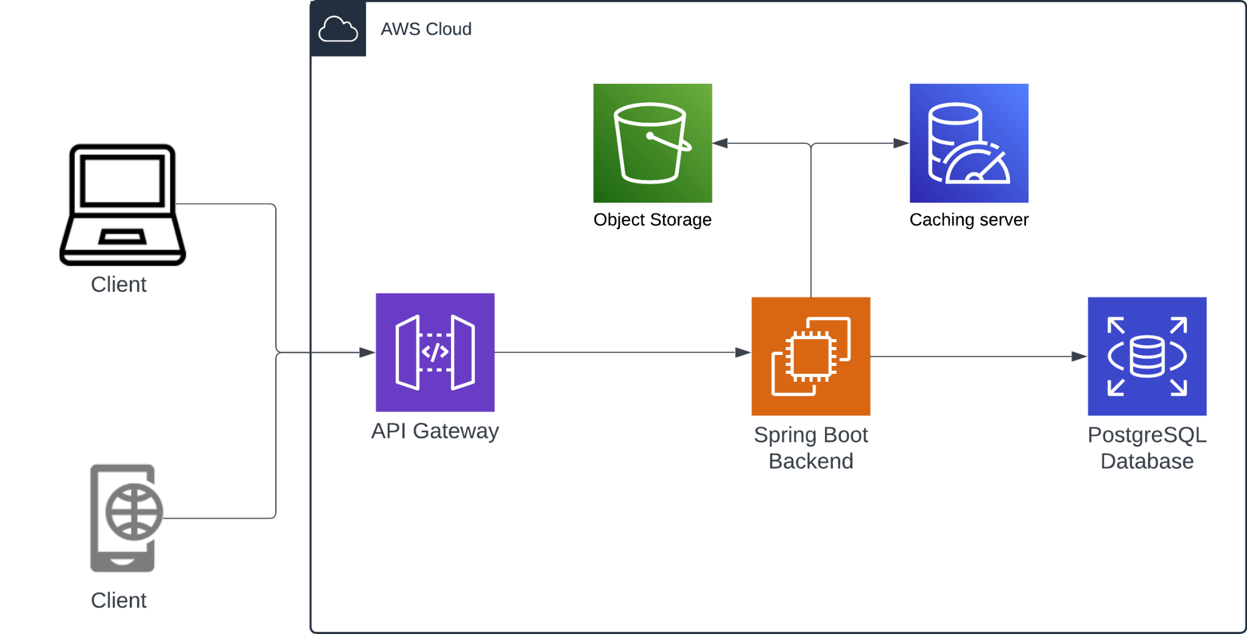

Figure : System Architecture for the PiXL App System

# SYSTEM MODELLING

## USE CASE DIAGRMS

### Use Cases

The following use case diagram shows the use cases involved in the PiXL app system.

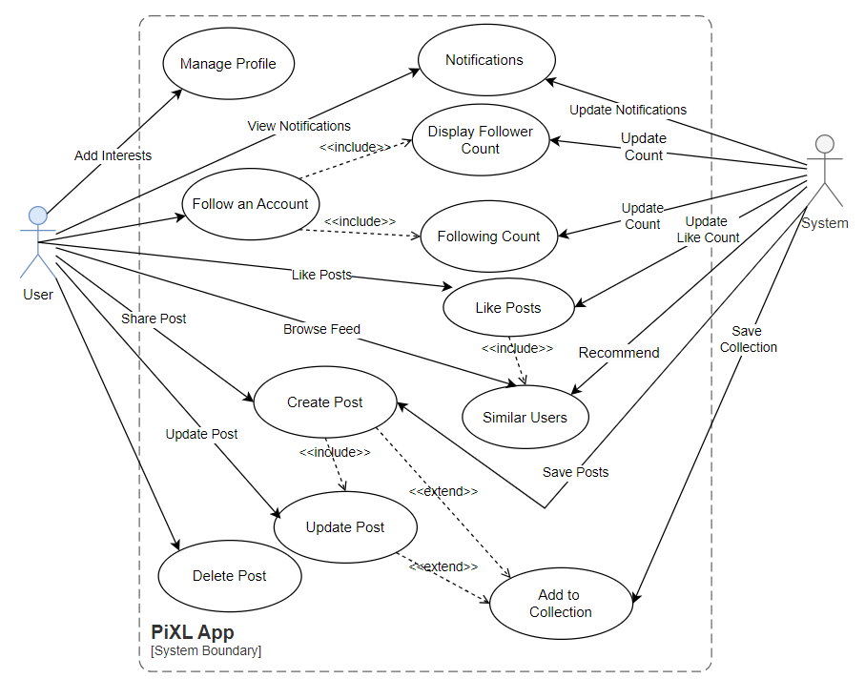

Figure : Use Cases for the PiXL App

### Use Case Diagrams

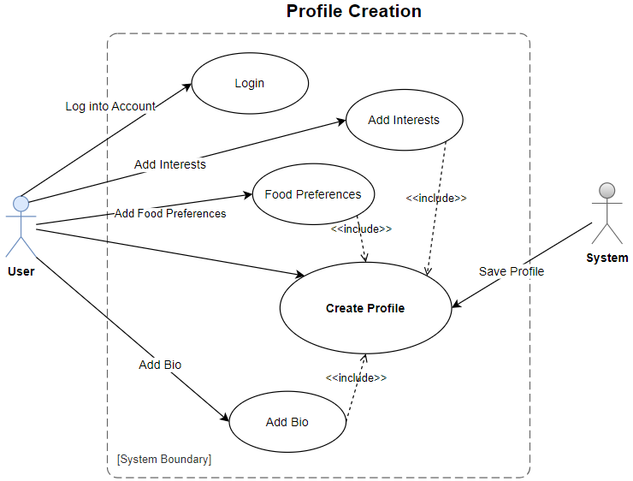

Figure : Profile Creation Use Case Diagram

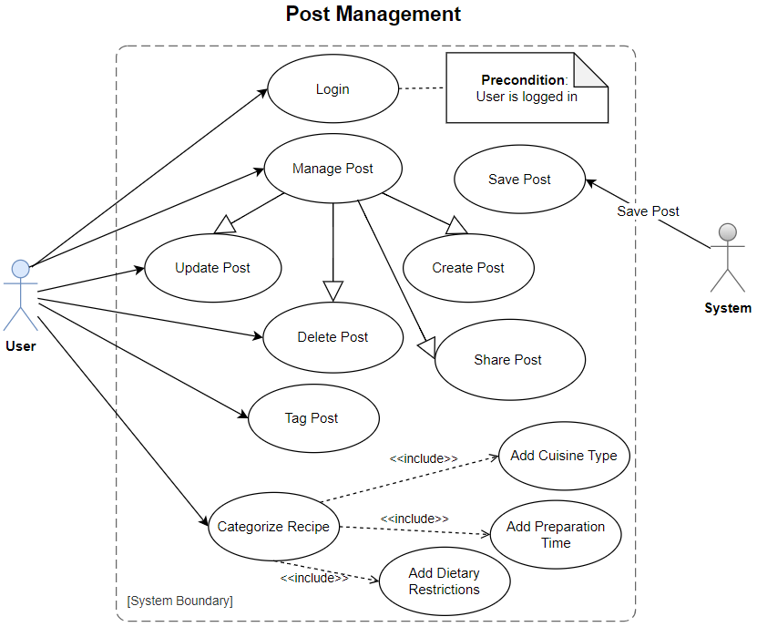

Figure : Post Management Use Case Diagram

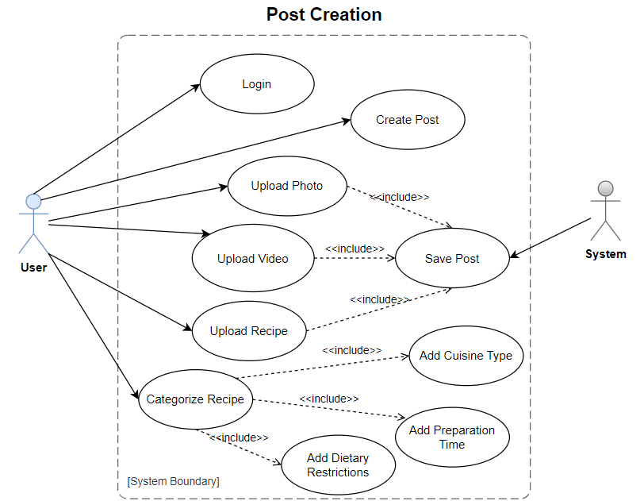

Figure : Post Creation Use Case Diagram

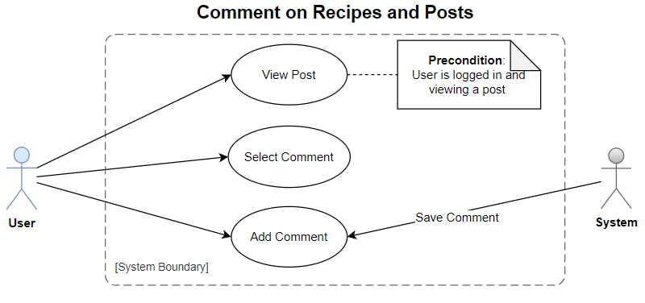

Figure : Comment on Posts and Recipes Use Case Diagram

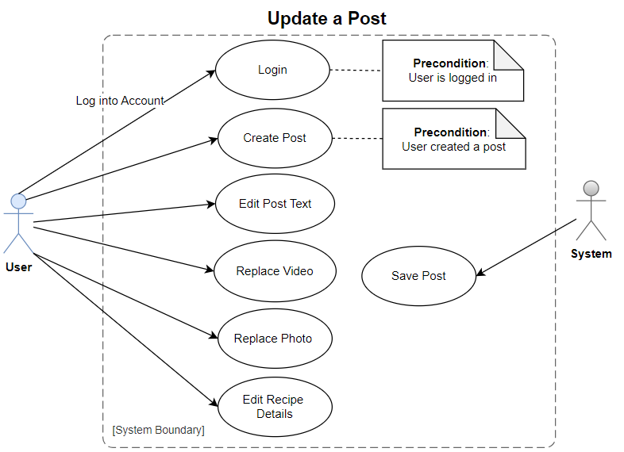

Figure : Update a Post Use Case Diagram

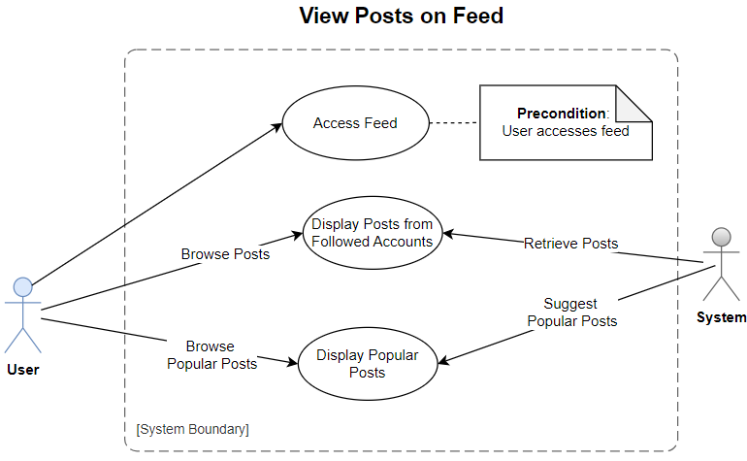

Figure : View Posts on Feed Use Case Diagram

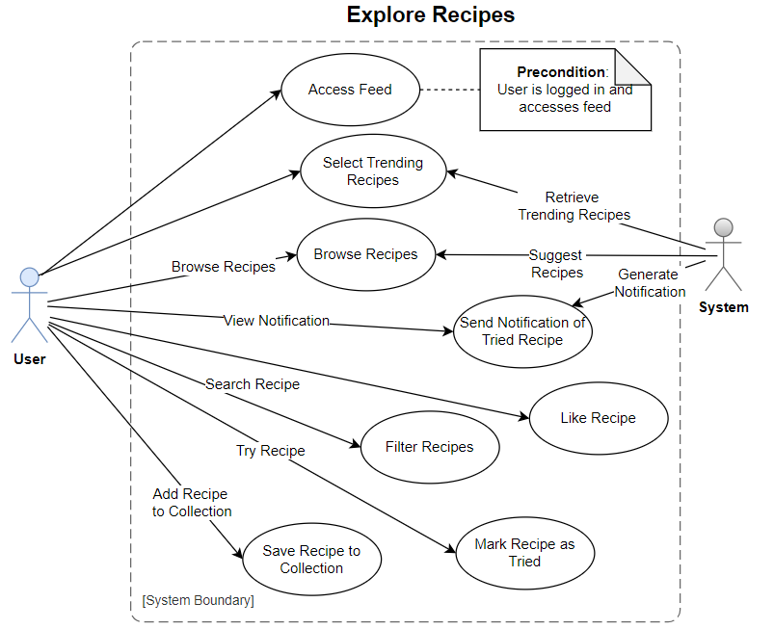

Figure : Explore Recipes Use Case Diagram

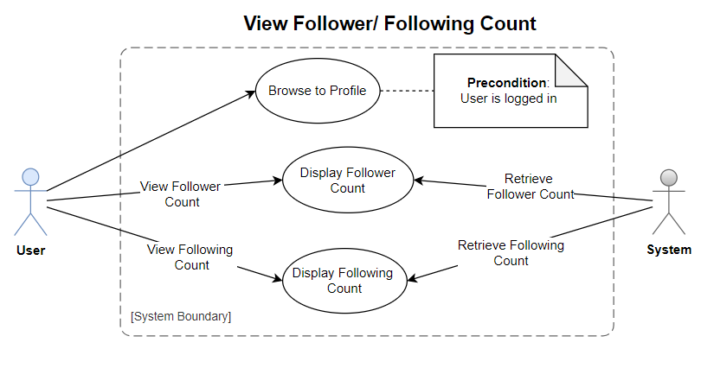

Figure : View Following/ Follower Count Use Case Diagram

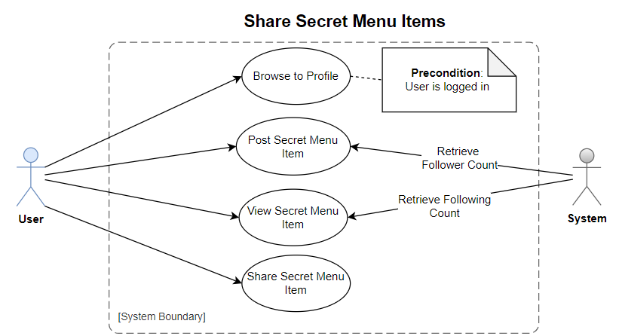

Figure : Share Secret Menu Item

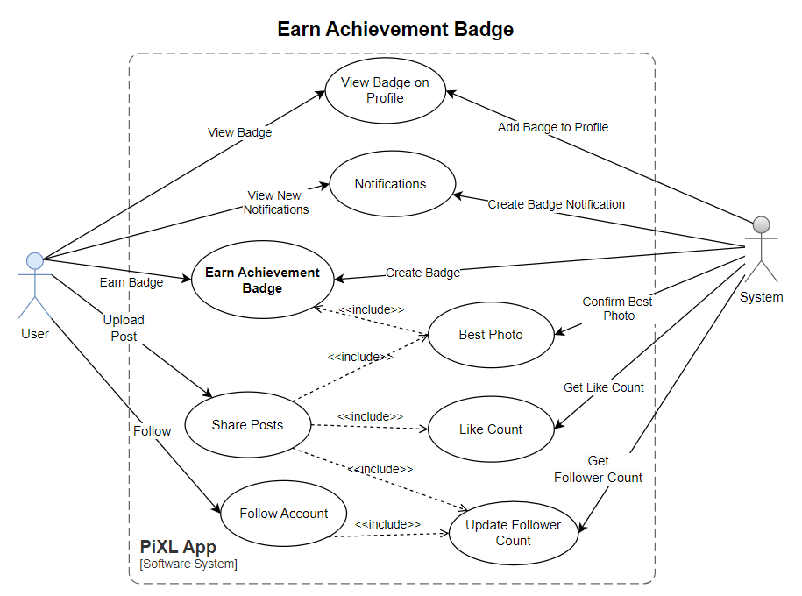

Figure : Earn Achievement Badge Use Case Diagram

## SEQUENCE DIAGRAMS

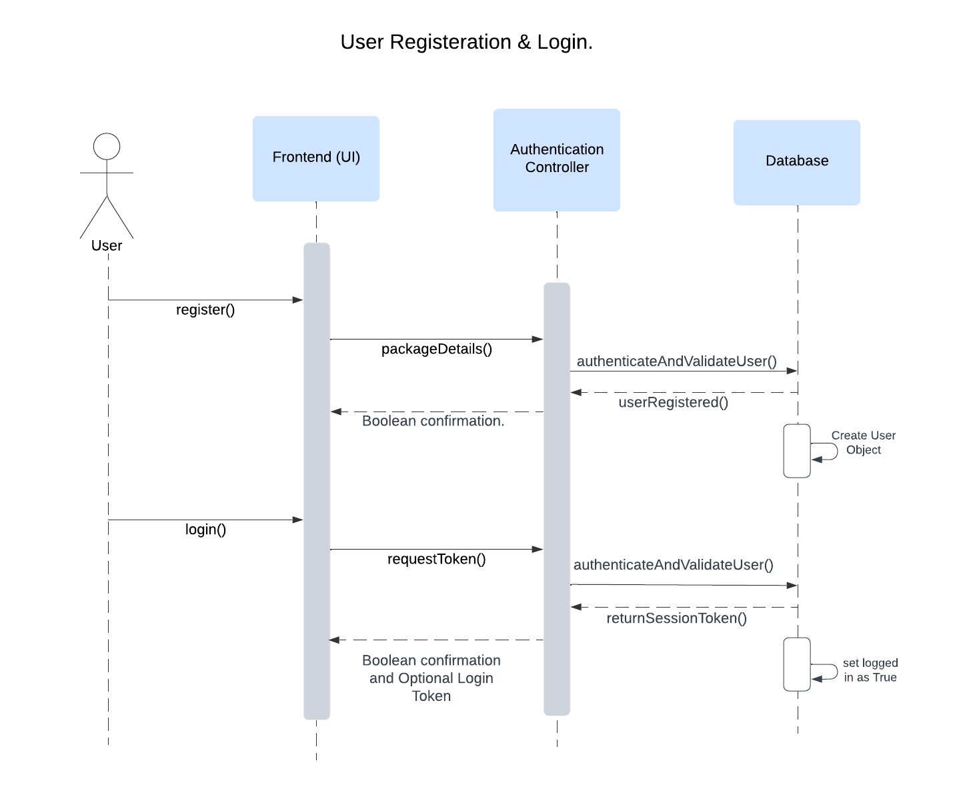

Figure : User Registration and Login Sequence Diagram

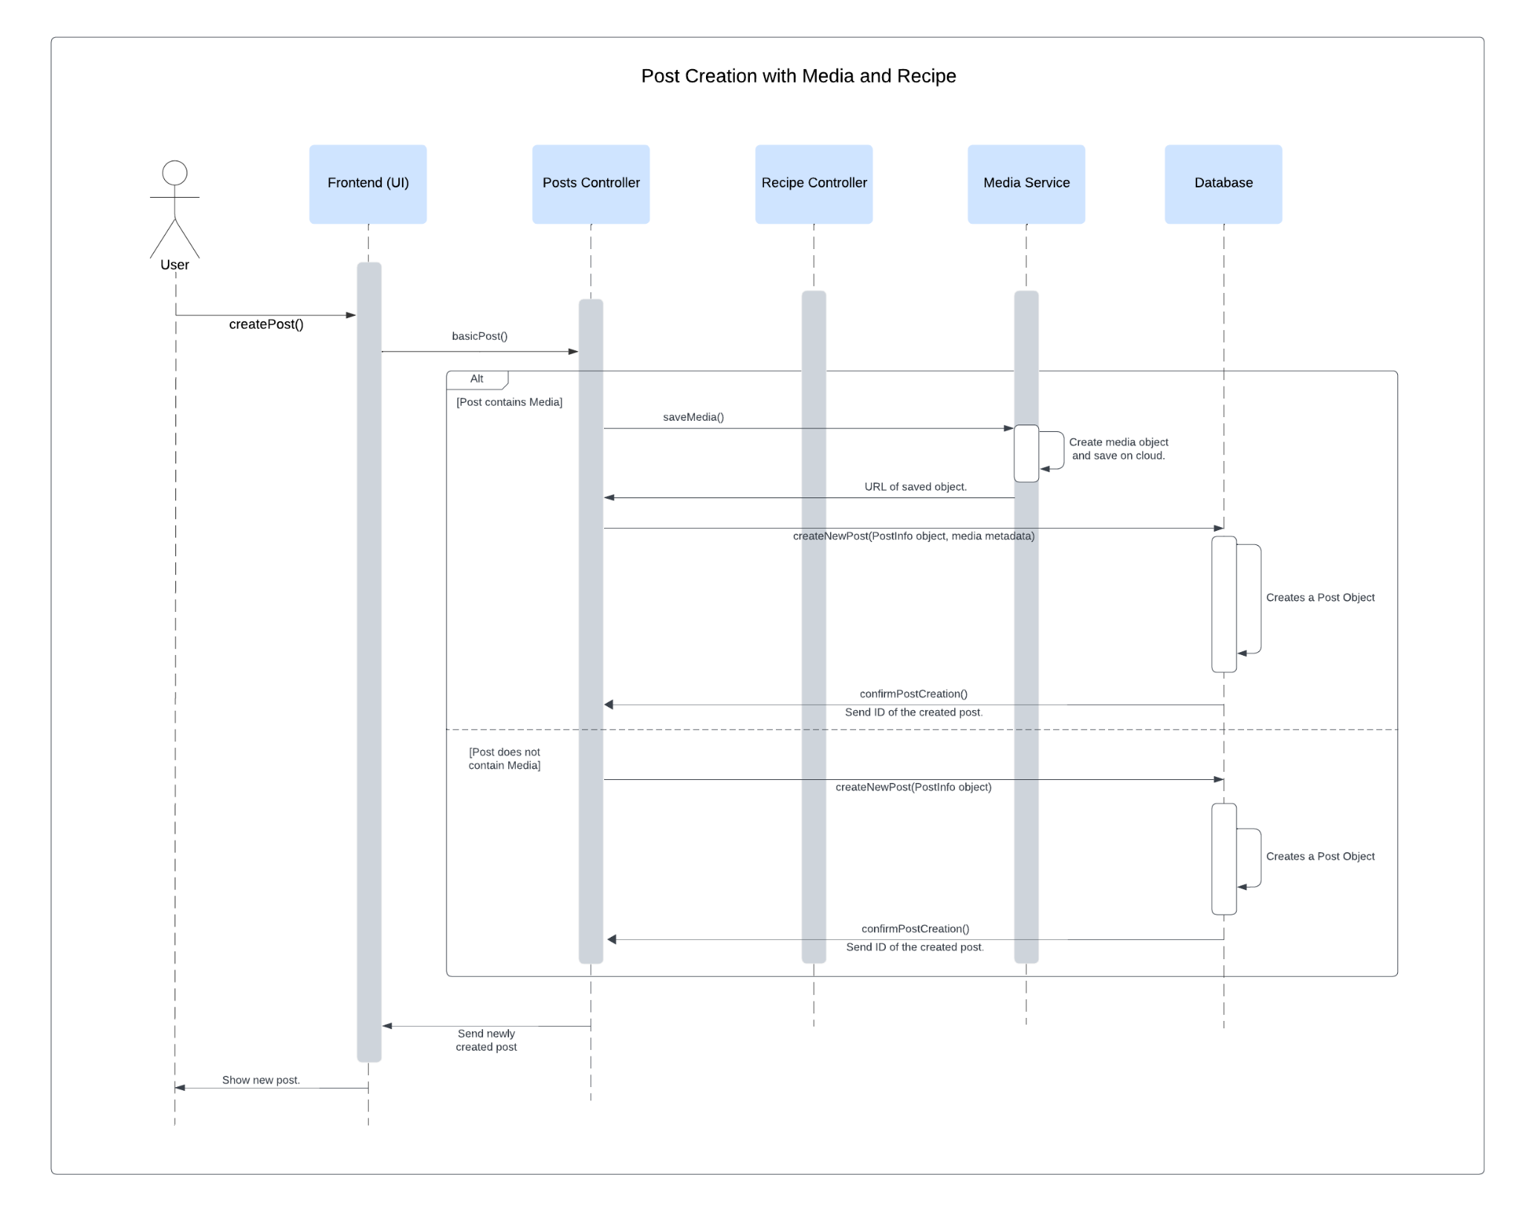

Figure : Post Creation with Media and Recipe Sequence Diagram

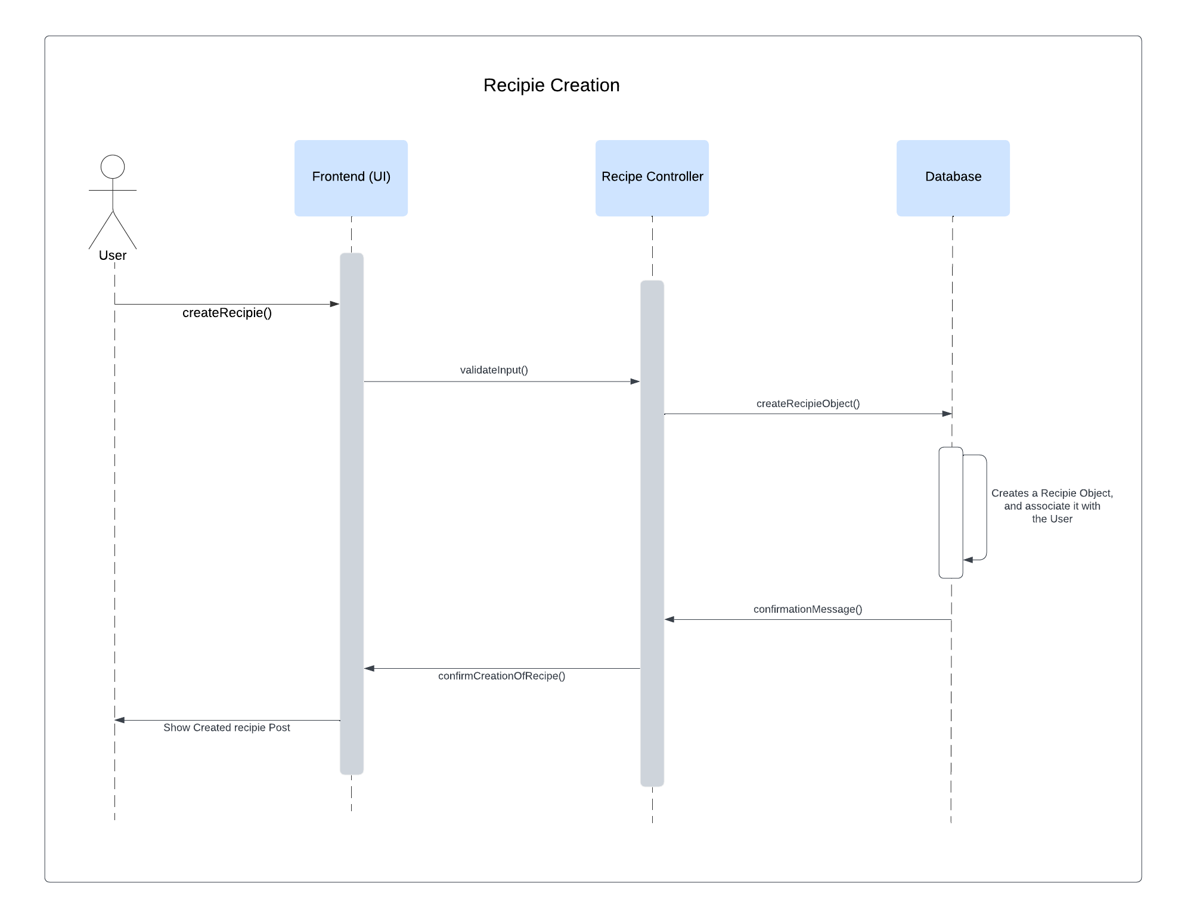

Figure : Recipe Creation Sequence Diagram

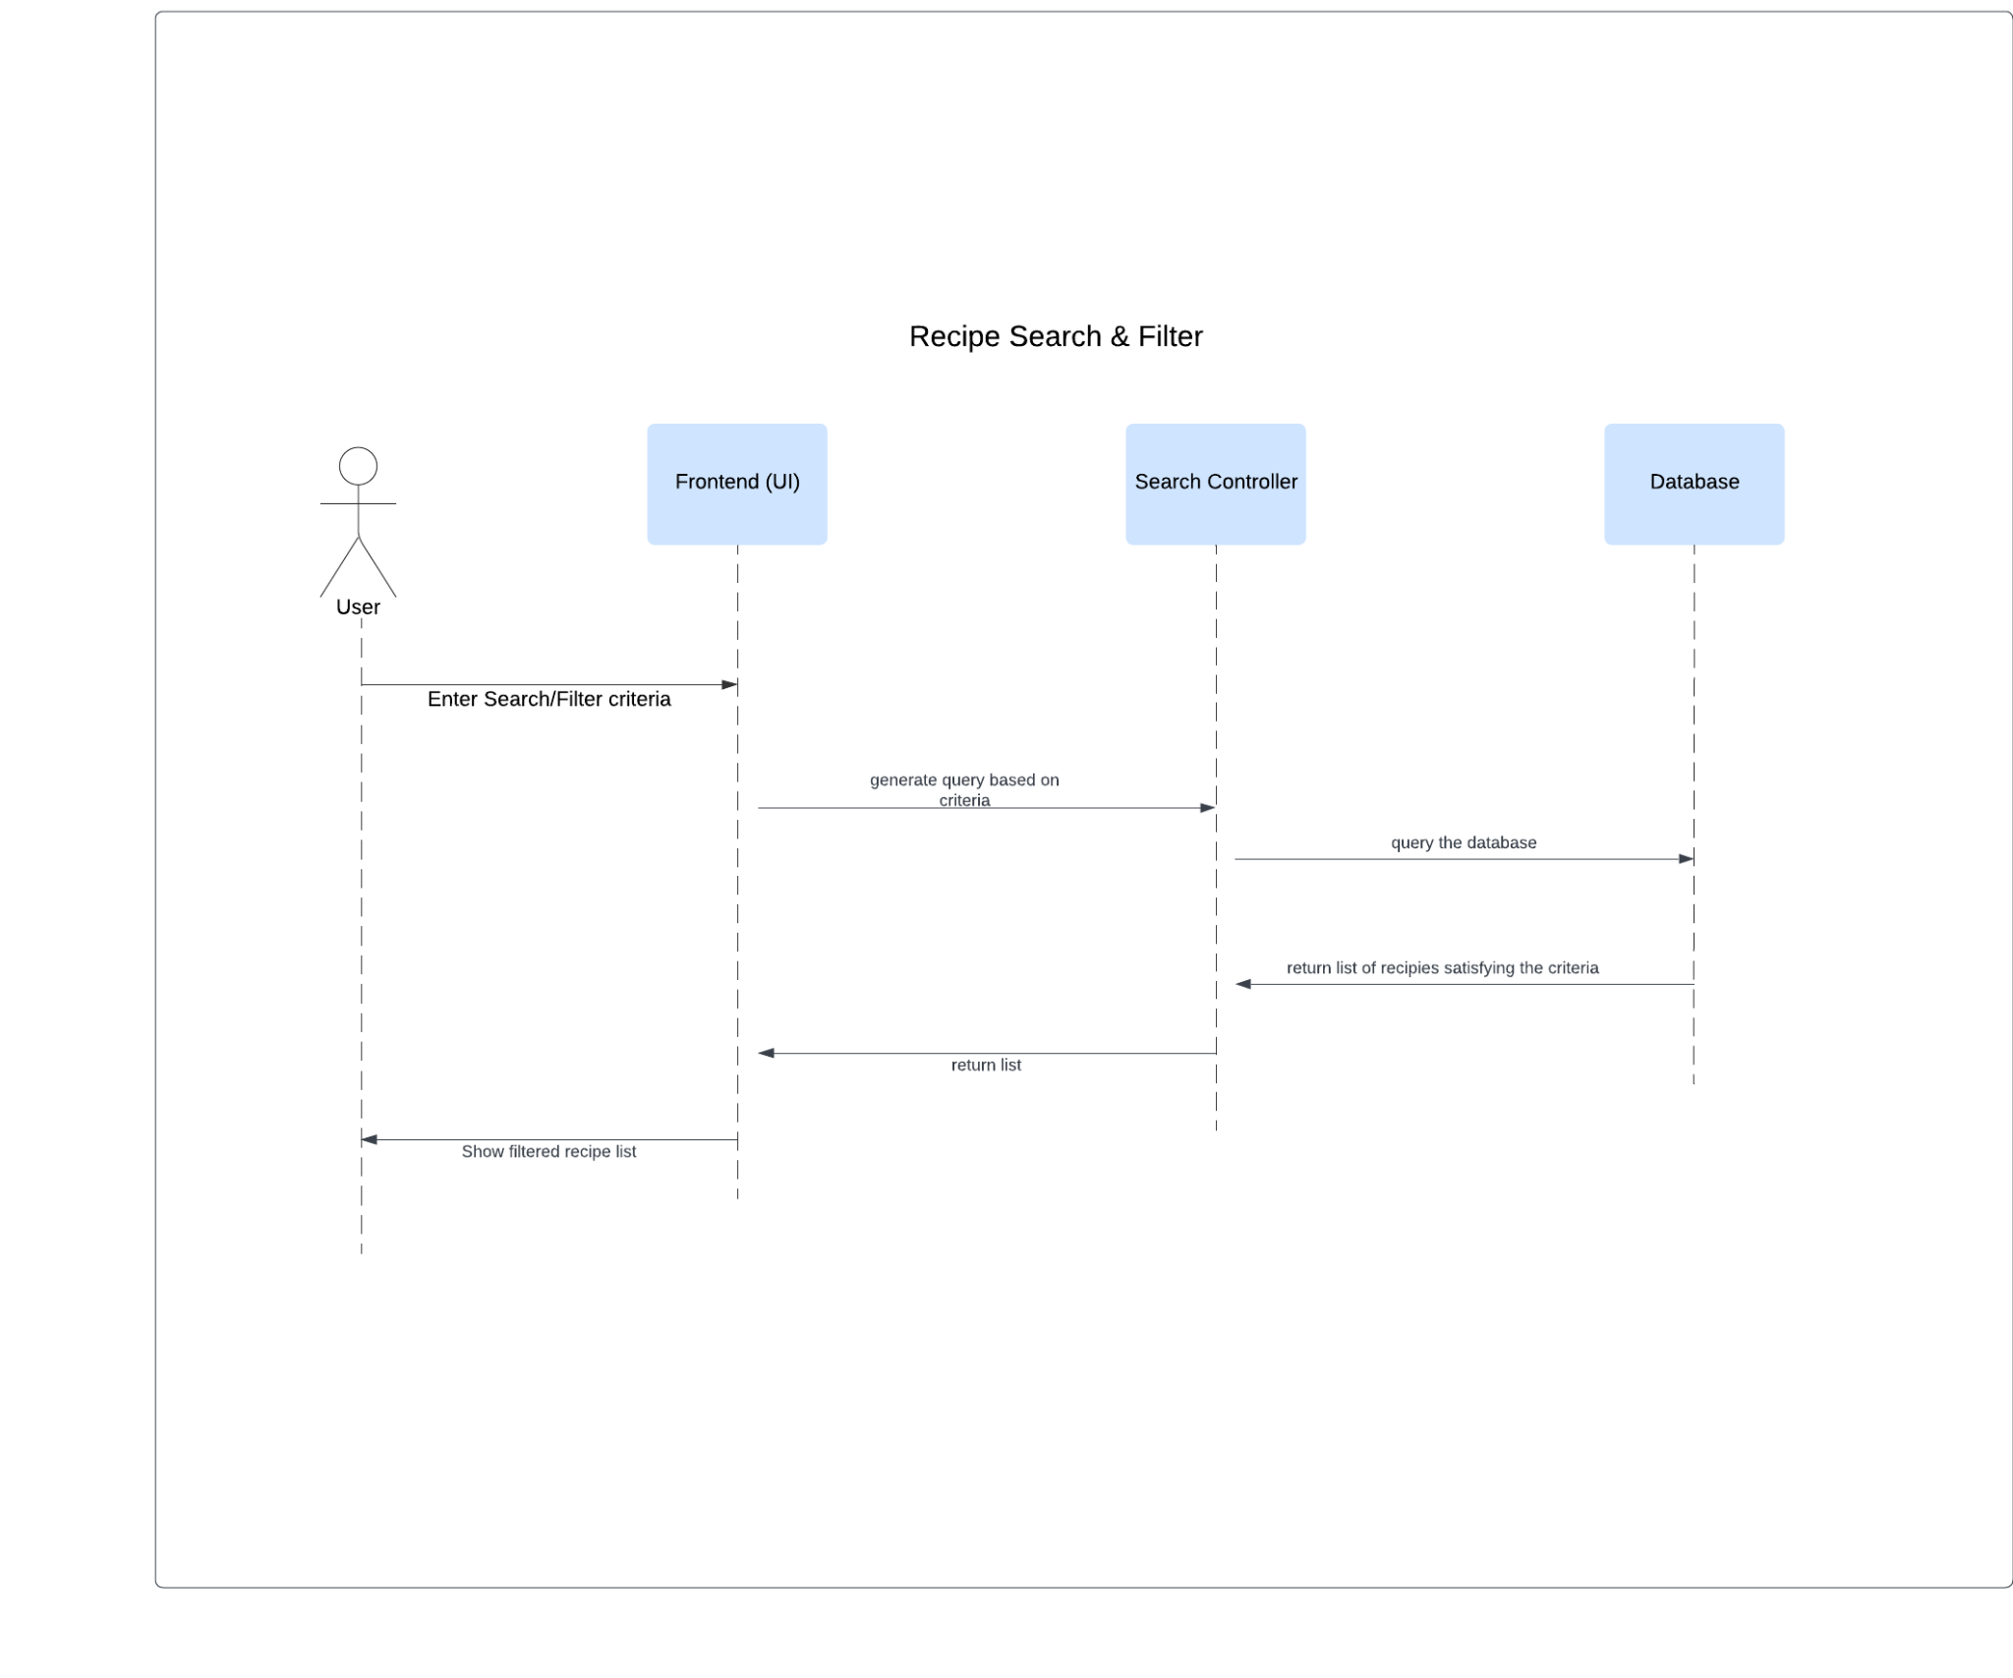

Figure : Recipe Search and Filter Sequence Diagram

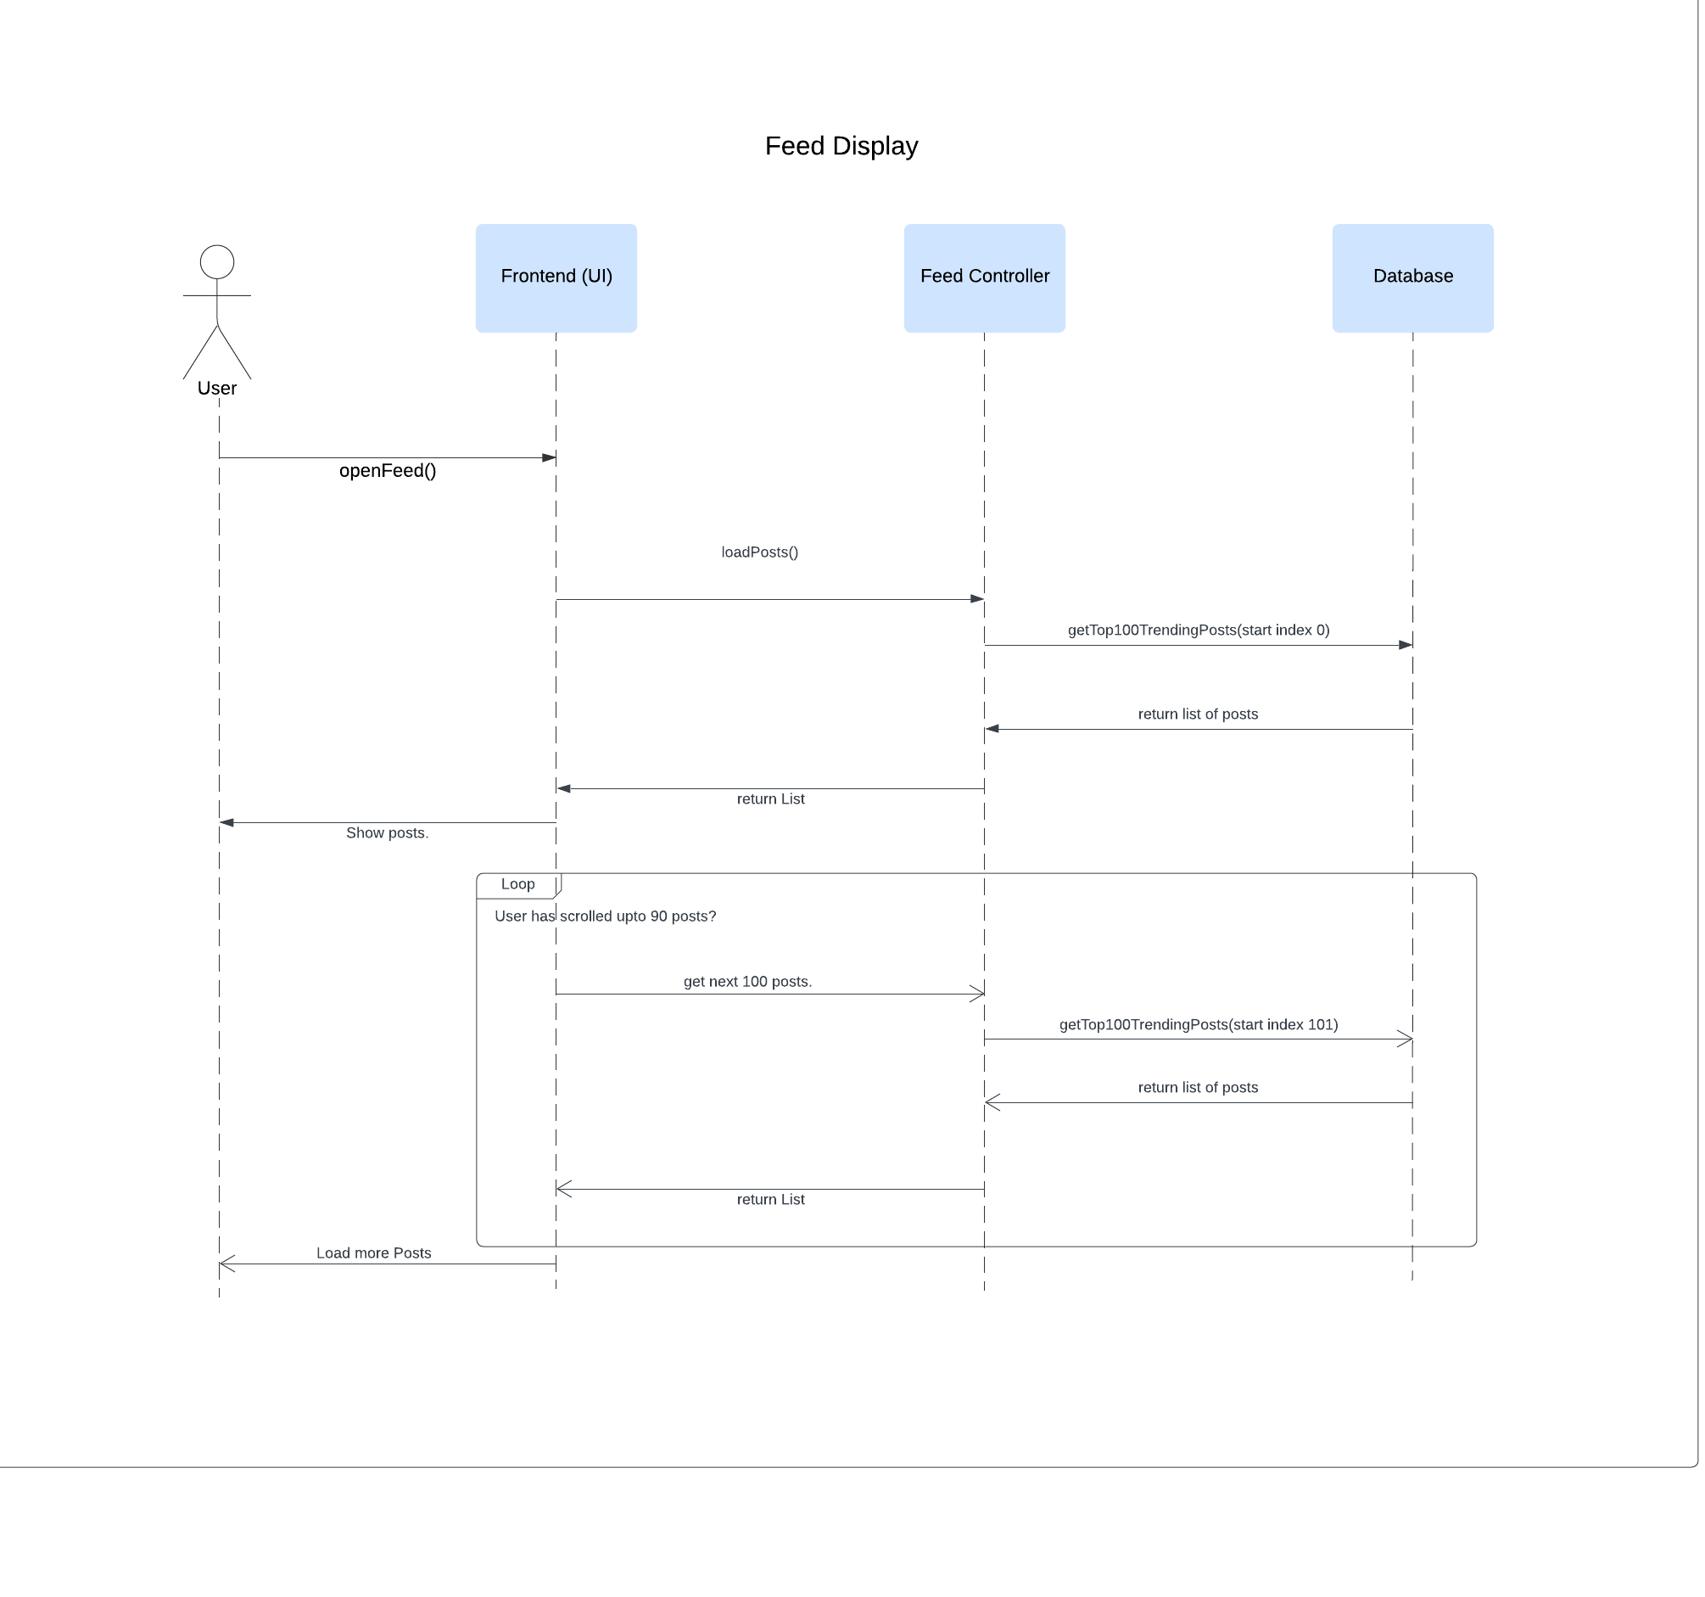

Figure : Feed Display Sequence Diagram

## CLASS DIAGRAMS

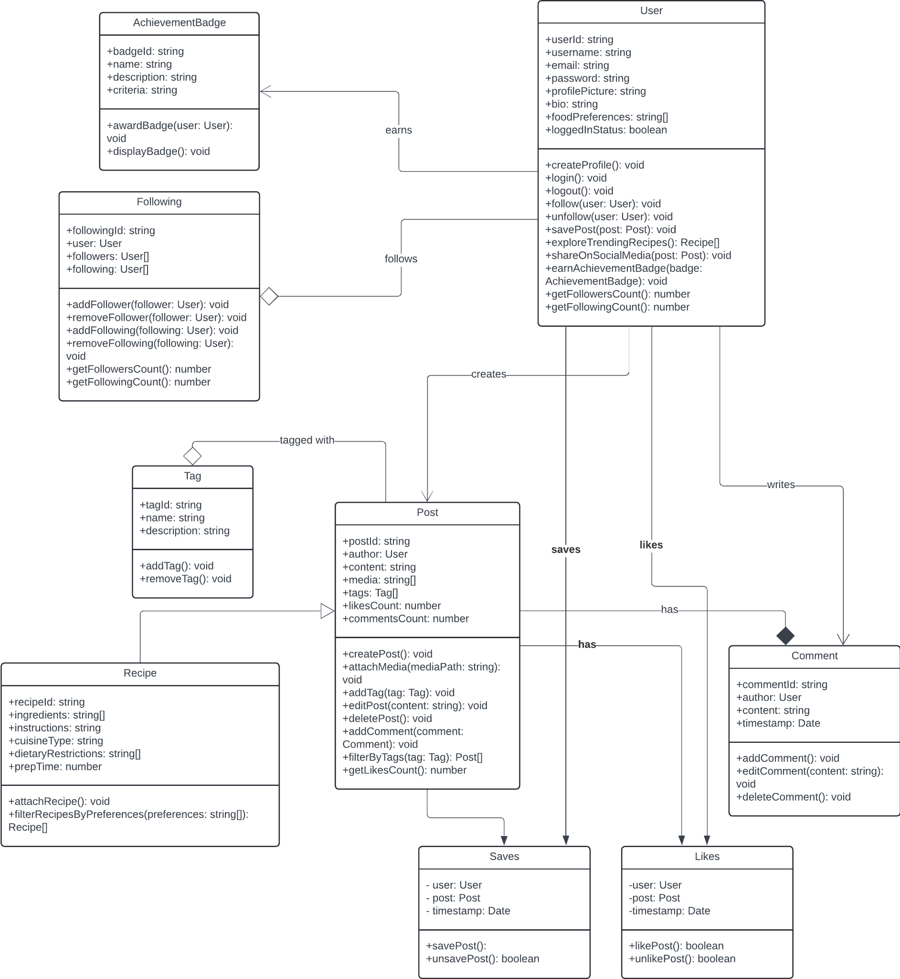

Figure : PiXL App Class Diagrams